**Computer Engineering**

**EGCP 471 MULTIDISCIPLINARY PROJECTS SPRING 2019**

**IN COMPUTER ENGINEERING – II**

**FORMAL PROJECT REPORT**

**VOICE CONTROLLED SHOWER**

**CORY LONGSHORE**

**JAMES PEREZ**

**HUGO SIMON**

**JESSICA DIAZ**

**TABLE OF CONTENTS PAGE**

**ABSTRACT** **2**

**BACKGROUND** **2**

**DESIGN GOALS** **2**

**DESIGN SPECIFICATION** **2**

**BLOCK DIAGRAM AND FUNCTIONAL EXPLANATION** **4**

**SCHEMATICS 5**

**FLOWCHART 8**

**PARTS LIST** **9**

**PHOTOS** **10**

**DISCUSSION OF RESULTS** **13**

**PROBLEMS ENCOUNTERED** **13**

**INDIVIDUAL TASK ASSIGNMENTS** **14**

**CONCLUSION** **14**

**FUTURE WORK** **14**

**REFERENCES** **15**

# 

# 

# ABSTRACT

We have been designing and building a motorized track to operate a shower by use of voice recognition and a web page controller. Our prototype will control a shower head on a motorized track, open and close water valves, and control the temperature of the water. To accomplish this we are implementing the voice controls by interfacing with Alexa, Amazon’s AI, through the use of an Amazon Echo. The use of UDP Packets, will enable us to use our ESP8266s to communicate between the devices in order to activate the stepper motors, valves that will be utilized for the functionality of our design. Our prototype is currently behaving as expected with our web page controller and Alexa.

# BACKGROUND

Our Senior Design Project inspiration came from an DMD patient. This causes diminishing motor functions and limits mobility which requires the need for constant assistance. This inspired our design to try and improve the quality of life for anyone that requires assistance to do simple tasks, such as taking a shower. Our goal is to have the voice controls assist the user and remove the need for any additional help while showering. This would be beneficial for the elderly or anyone with disabilities that restricts their motor functions.

# DESIGN GOALS / SPECIFICATION

*CpE SO(2): An ability to apply engineering design to produce solutions that meet specified needs with consideration of public health, safety, and welfare, as well as global, cultural, social,   
environmental, and economic factors

SO(2): Our project gives us the ability to design and conduct experiments, as well as to analyze and interpret data by challenging us to create and implement an IoT device with an Arduino. We will be writing code to send commands from our microcontroller to the external motors. The external components will execute their function and return control to the AI. The AI will then send feedback in order to implement a busy/wait system to control our household appliance.

* **CpE SO(5)**: An ability to function effectively on a team whose members together provide leadership, create a collaborative and inclusive environment, establish goals, plan tasks, and meet objectives.

SO(5): It also gives us the ability to identify, formulate, and solve engineering problems by first brainstorming some type of problem that we can solve to be beneficial to the general population. Then, we came up with the idea to enable anyone with disabilities or limited movement the ability to require less assistance doing mundane tasks. The idea was to have a voice-enabled shower that would be able to control the shower and would possibly remove the need for extra assistance while in the shower. This solution to this problem is a quality of life improvement that many would consider very beneficial since it employs more self-dependence.

**\* CpE SO(7)**: An ability to acquire and apply new knowledge as needed, using appropriate learning strategies.

SO(7): During this project, we were able to use the knowledge that we acquired over the years that we have been studying. We each were able to put this knowledge to use by interacting with the arduinos, communicating with the ESPs, and even interfacing with Alexa. Using what we learned, we successfully interconnected the Arduinos, water valves, ESPs, and Alexa AI Only through these studies were we able to acquire and apply the knowledge needed to tackle this complex project.

# BLOCK DIAGRAM AND FUNCTIONAL EXPLANATION



**Figure 1**

Fig. 1 contains the components that will allow the use of voice command and a web application to control the water temperature, the shower head placement and the Servo Motor for the shower head angle.

# 

# SCHEMATICS

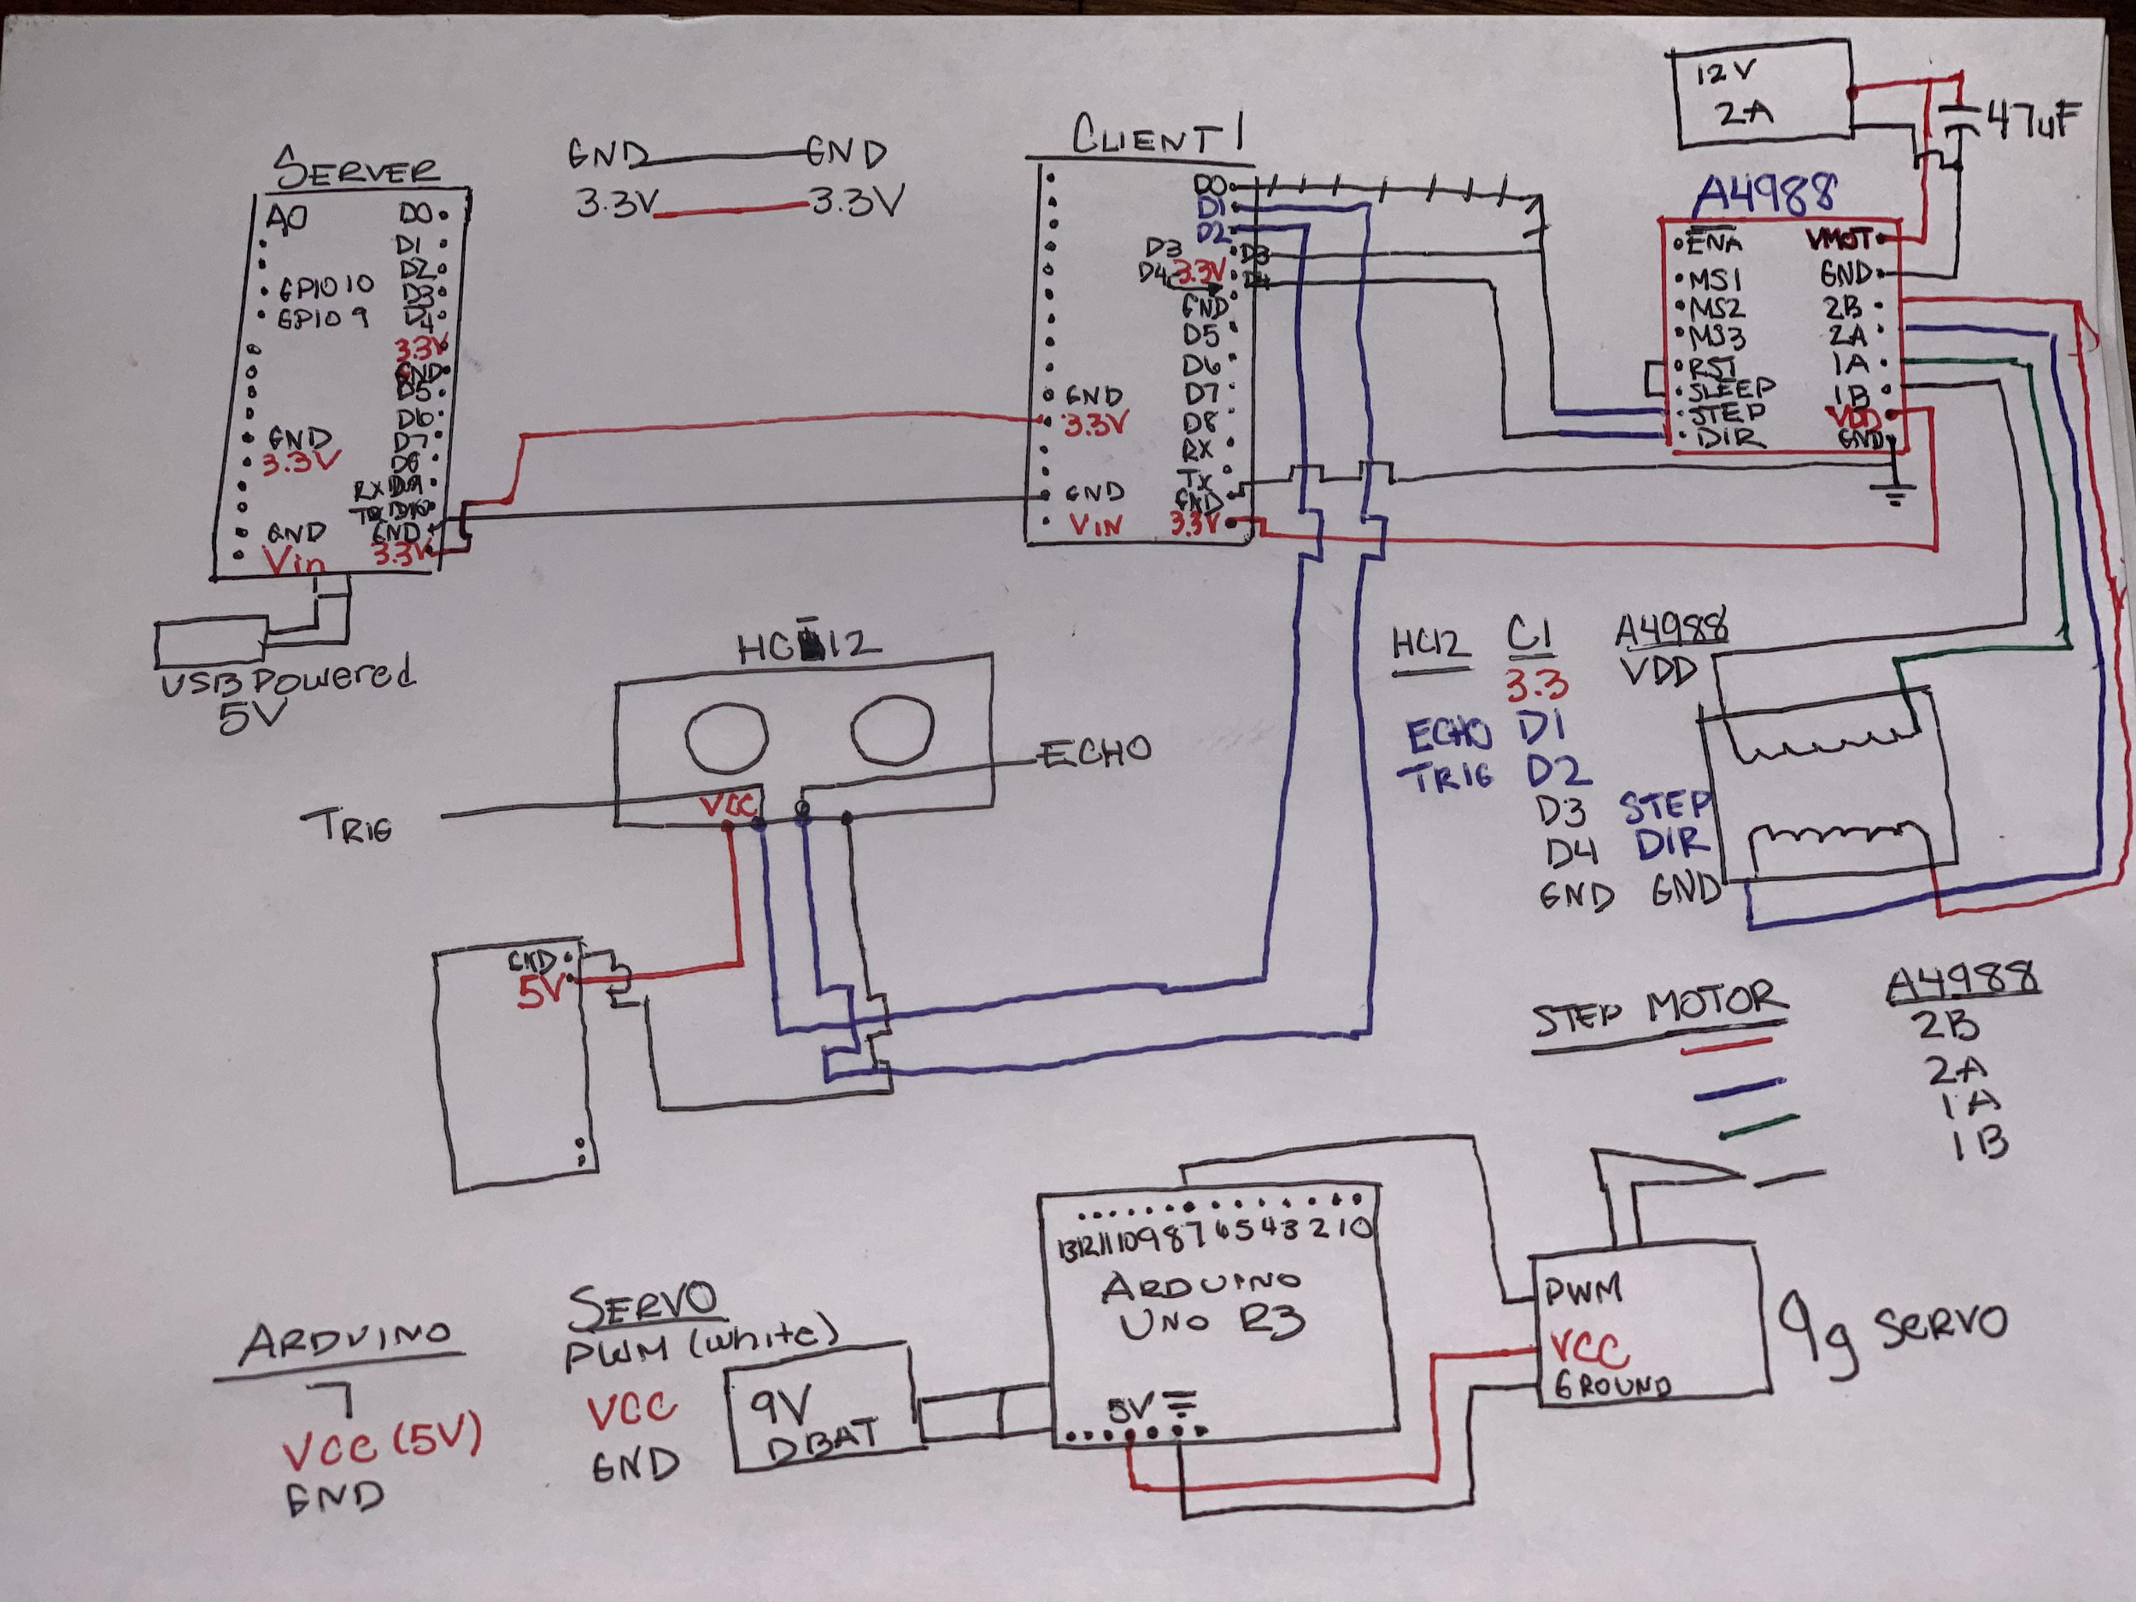

**Figure 2**

This schematic in Figure 2 will help us control the shower head movement on the sliding track that will be able to reposition itself, as well as control the distance of the showerhead from the beginning of the track, and the movement of the showerhead itself.

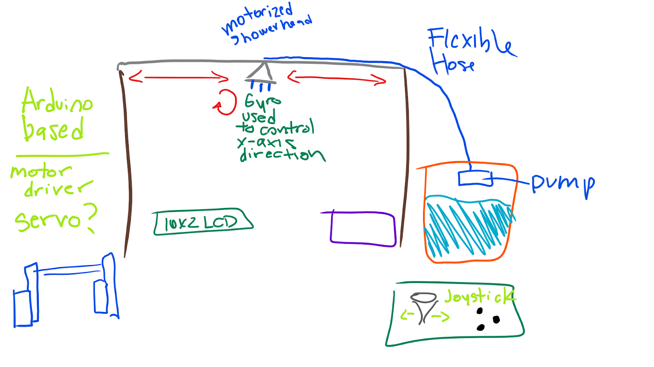

**Figure 3**

The image above in Figure 3 is an original design of our shower system. We thought to have a gyroscope measure the position and read it out on the LCD, as well as being able to articulate it with the joystick and pushbuttons. We ended up modifying this design greatly.

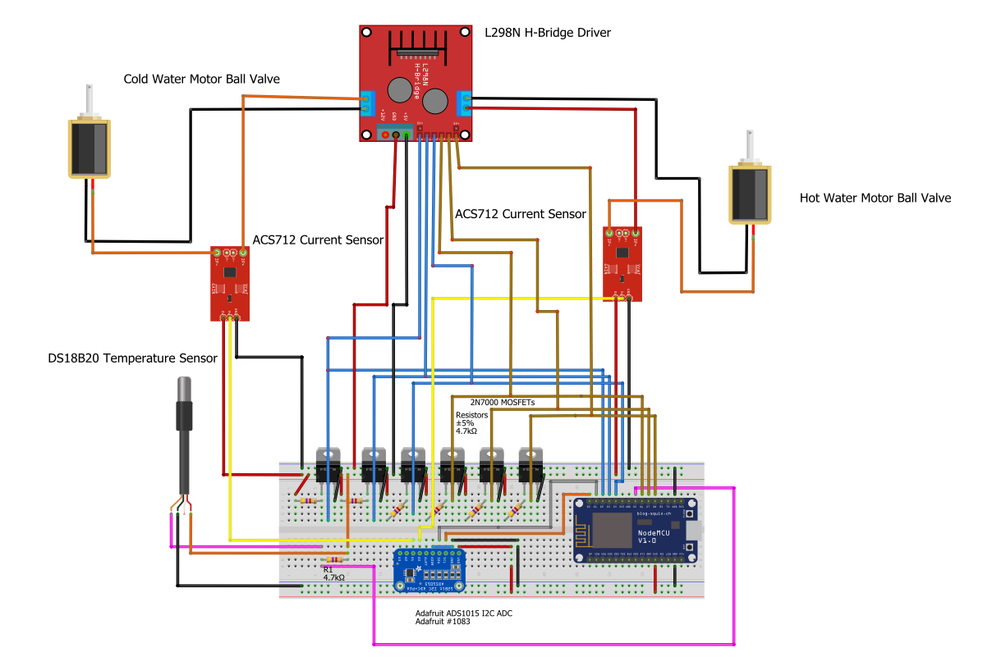

**Figure 4**

This schematic in Figure 4 will help us control the control valves that will be opening and closing to adjust the temperature of the water as well as the water pressure. In our case, we will be using an ESP8266 12E MCU 1.0, Motor Ball Valves, and a DS1820 Temperature Sensor.

**FLOW CHART**

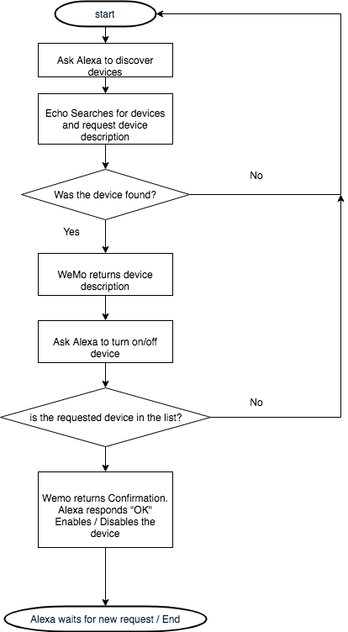

**Figure 5**

We are using the flowchart of Figure 5 to develop and interface our Alexa with our devices connected to our ESP8266s. To accomplish this we have to use the Arduino IDE to send and receive UDP packets along with the Fauxmo library to help with Belkin WeMo Emulation.

**PARTS LIST**

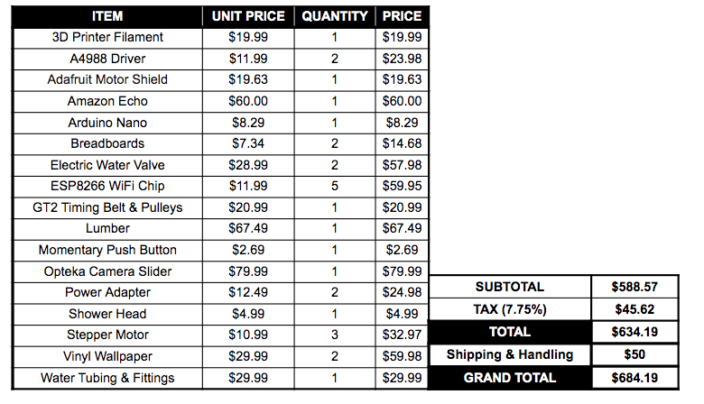

**Figure 6**

In Figure 6 we have listed our complete parts list with costs of our project. We were able to complete this project under our preliminary budget of $1018.21.

# 

# PHOTOS

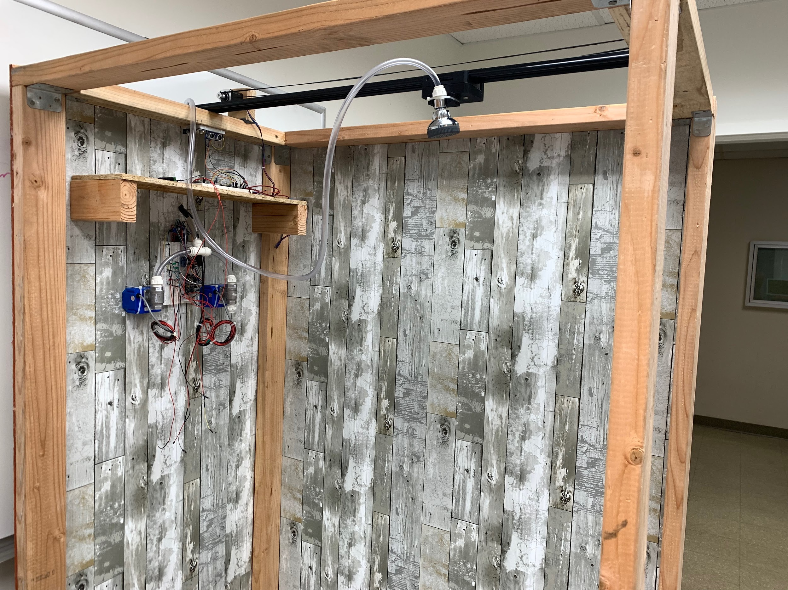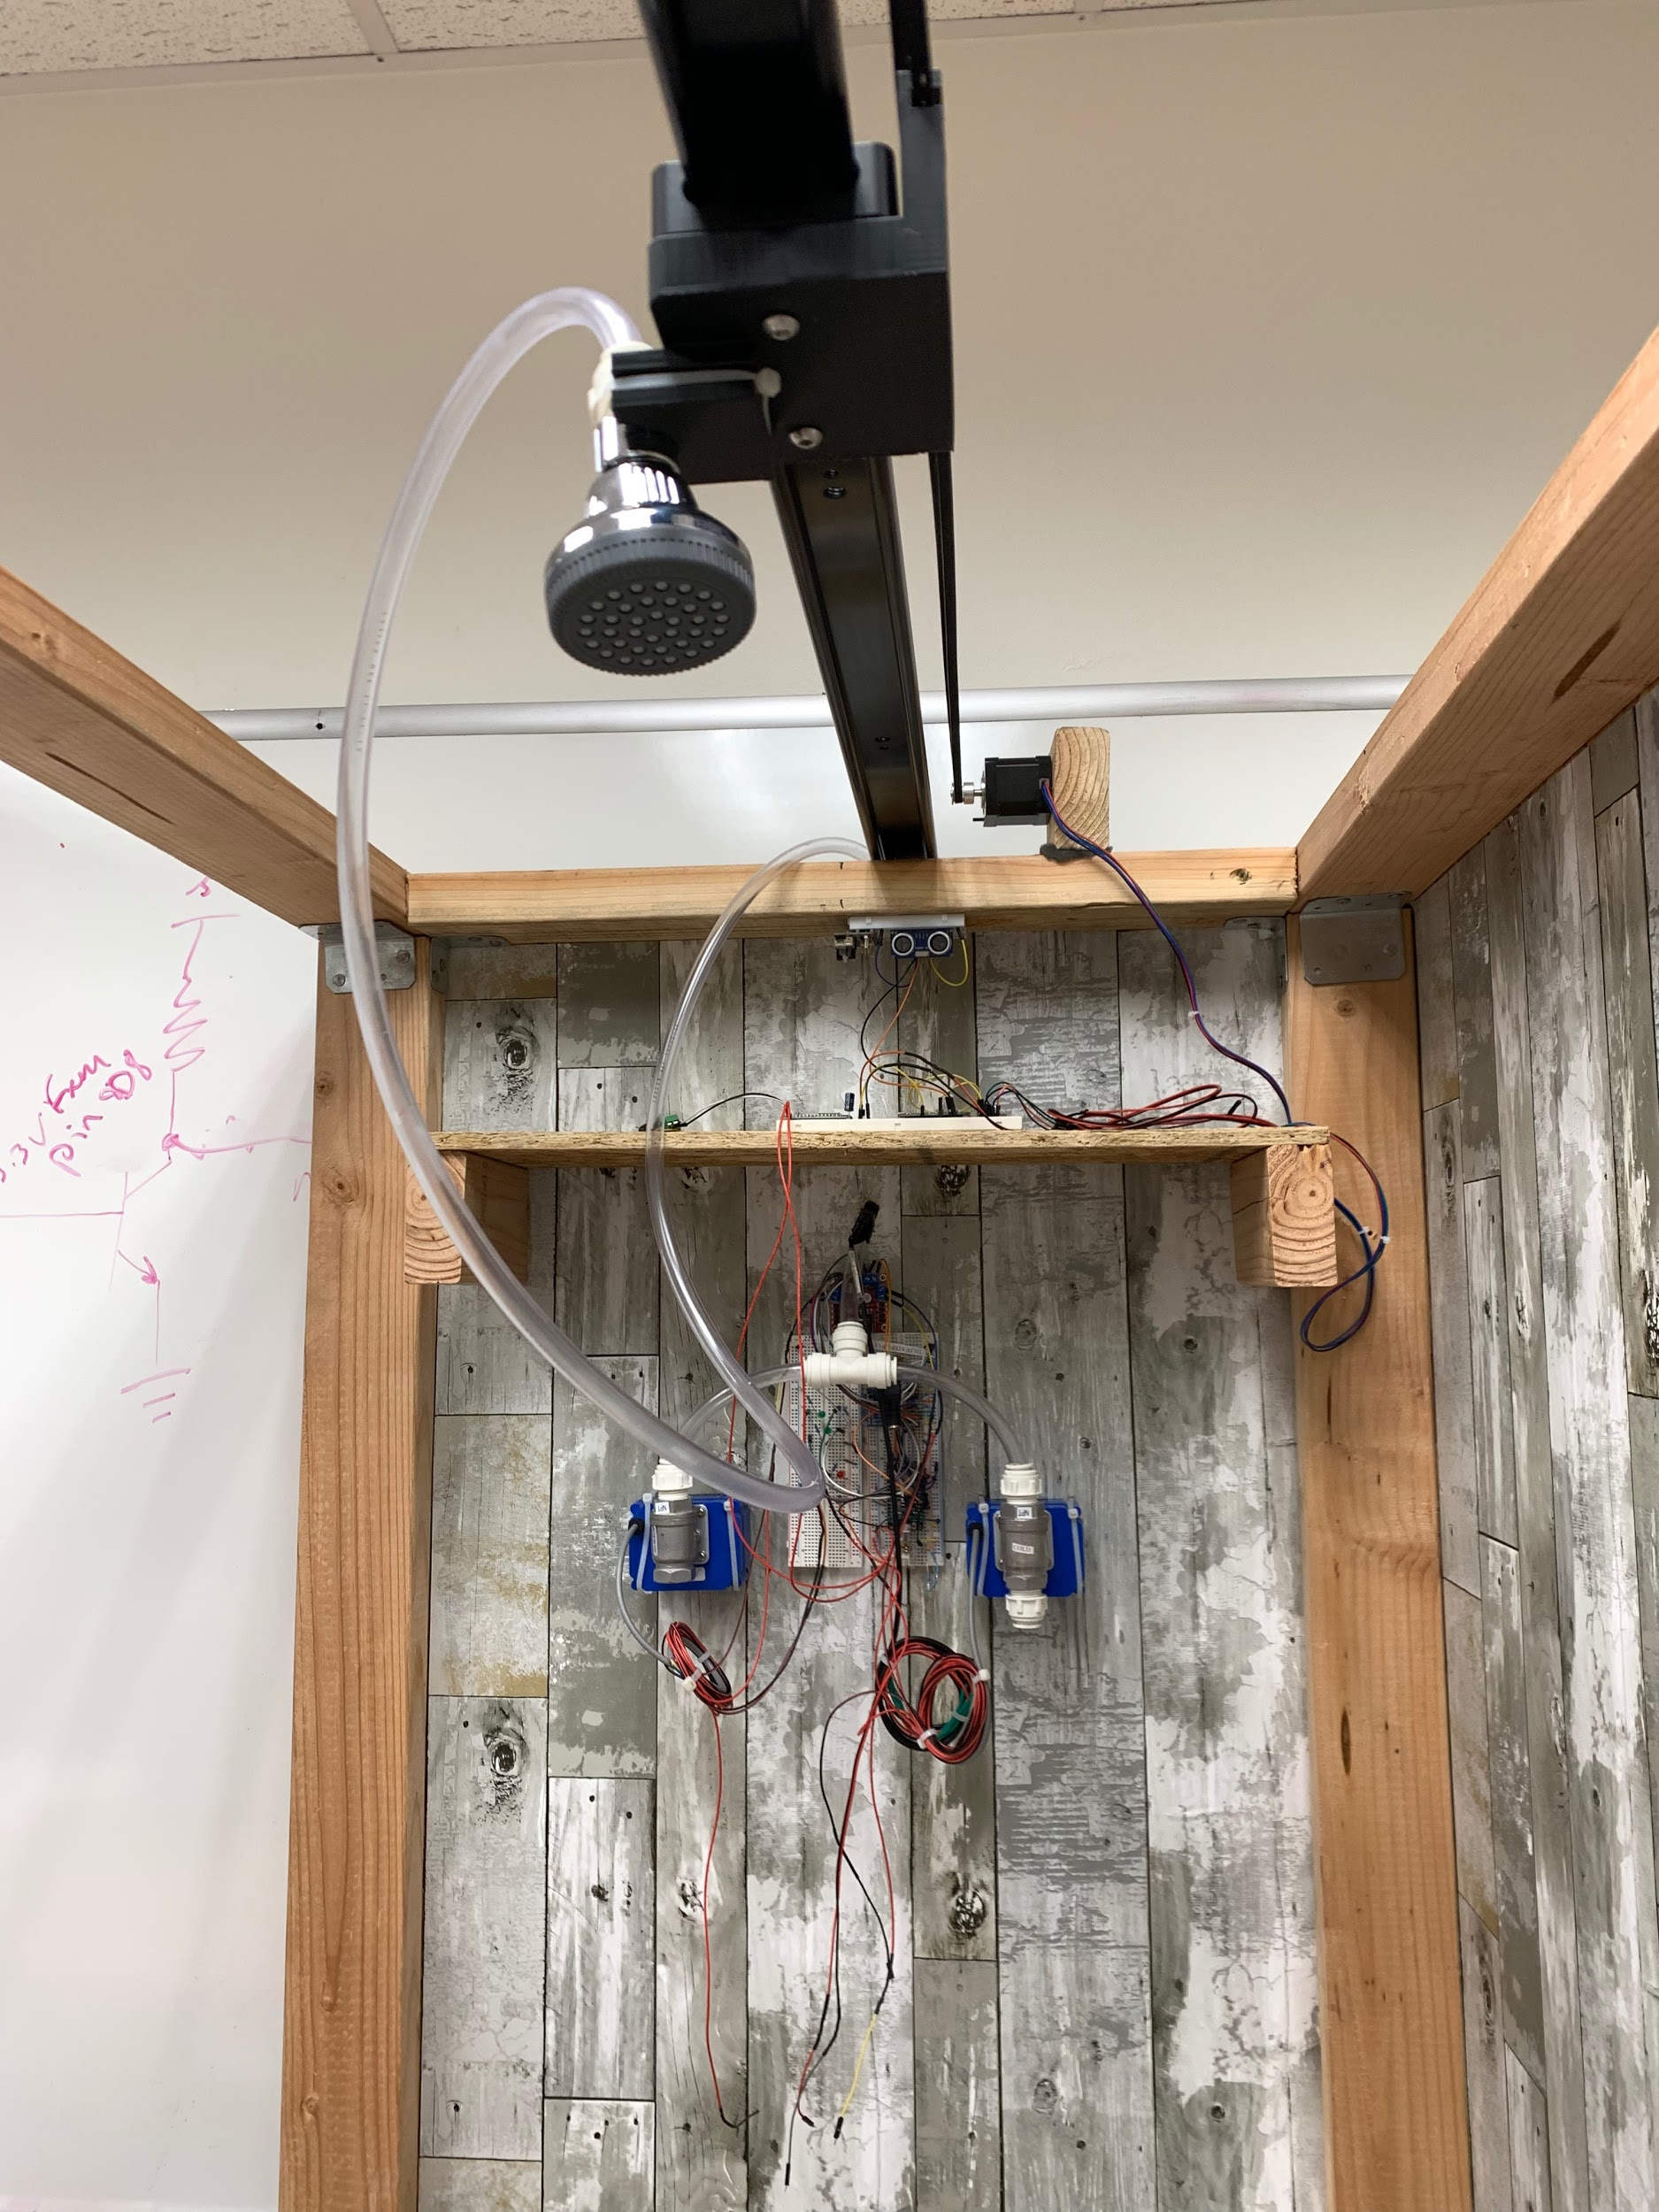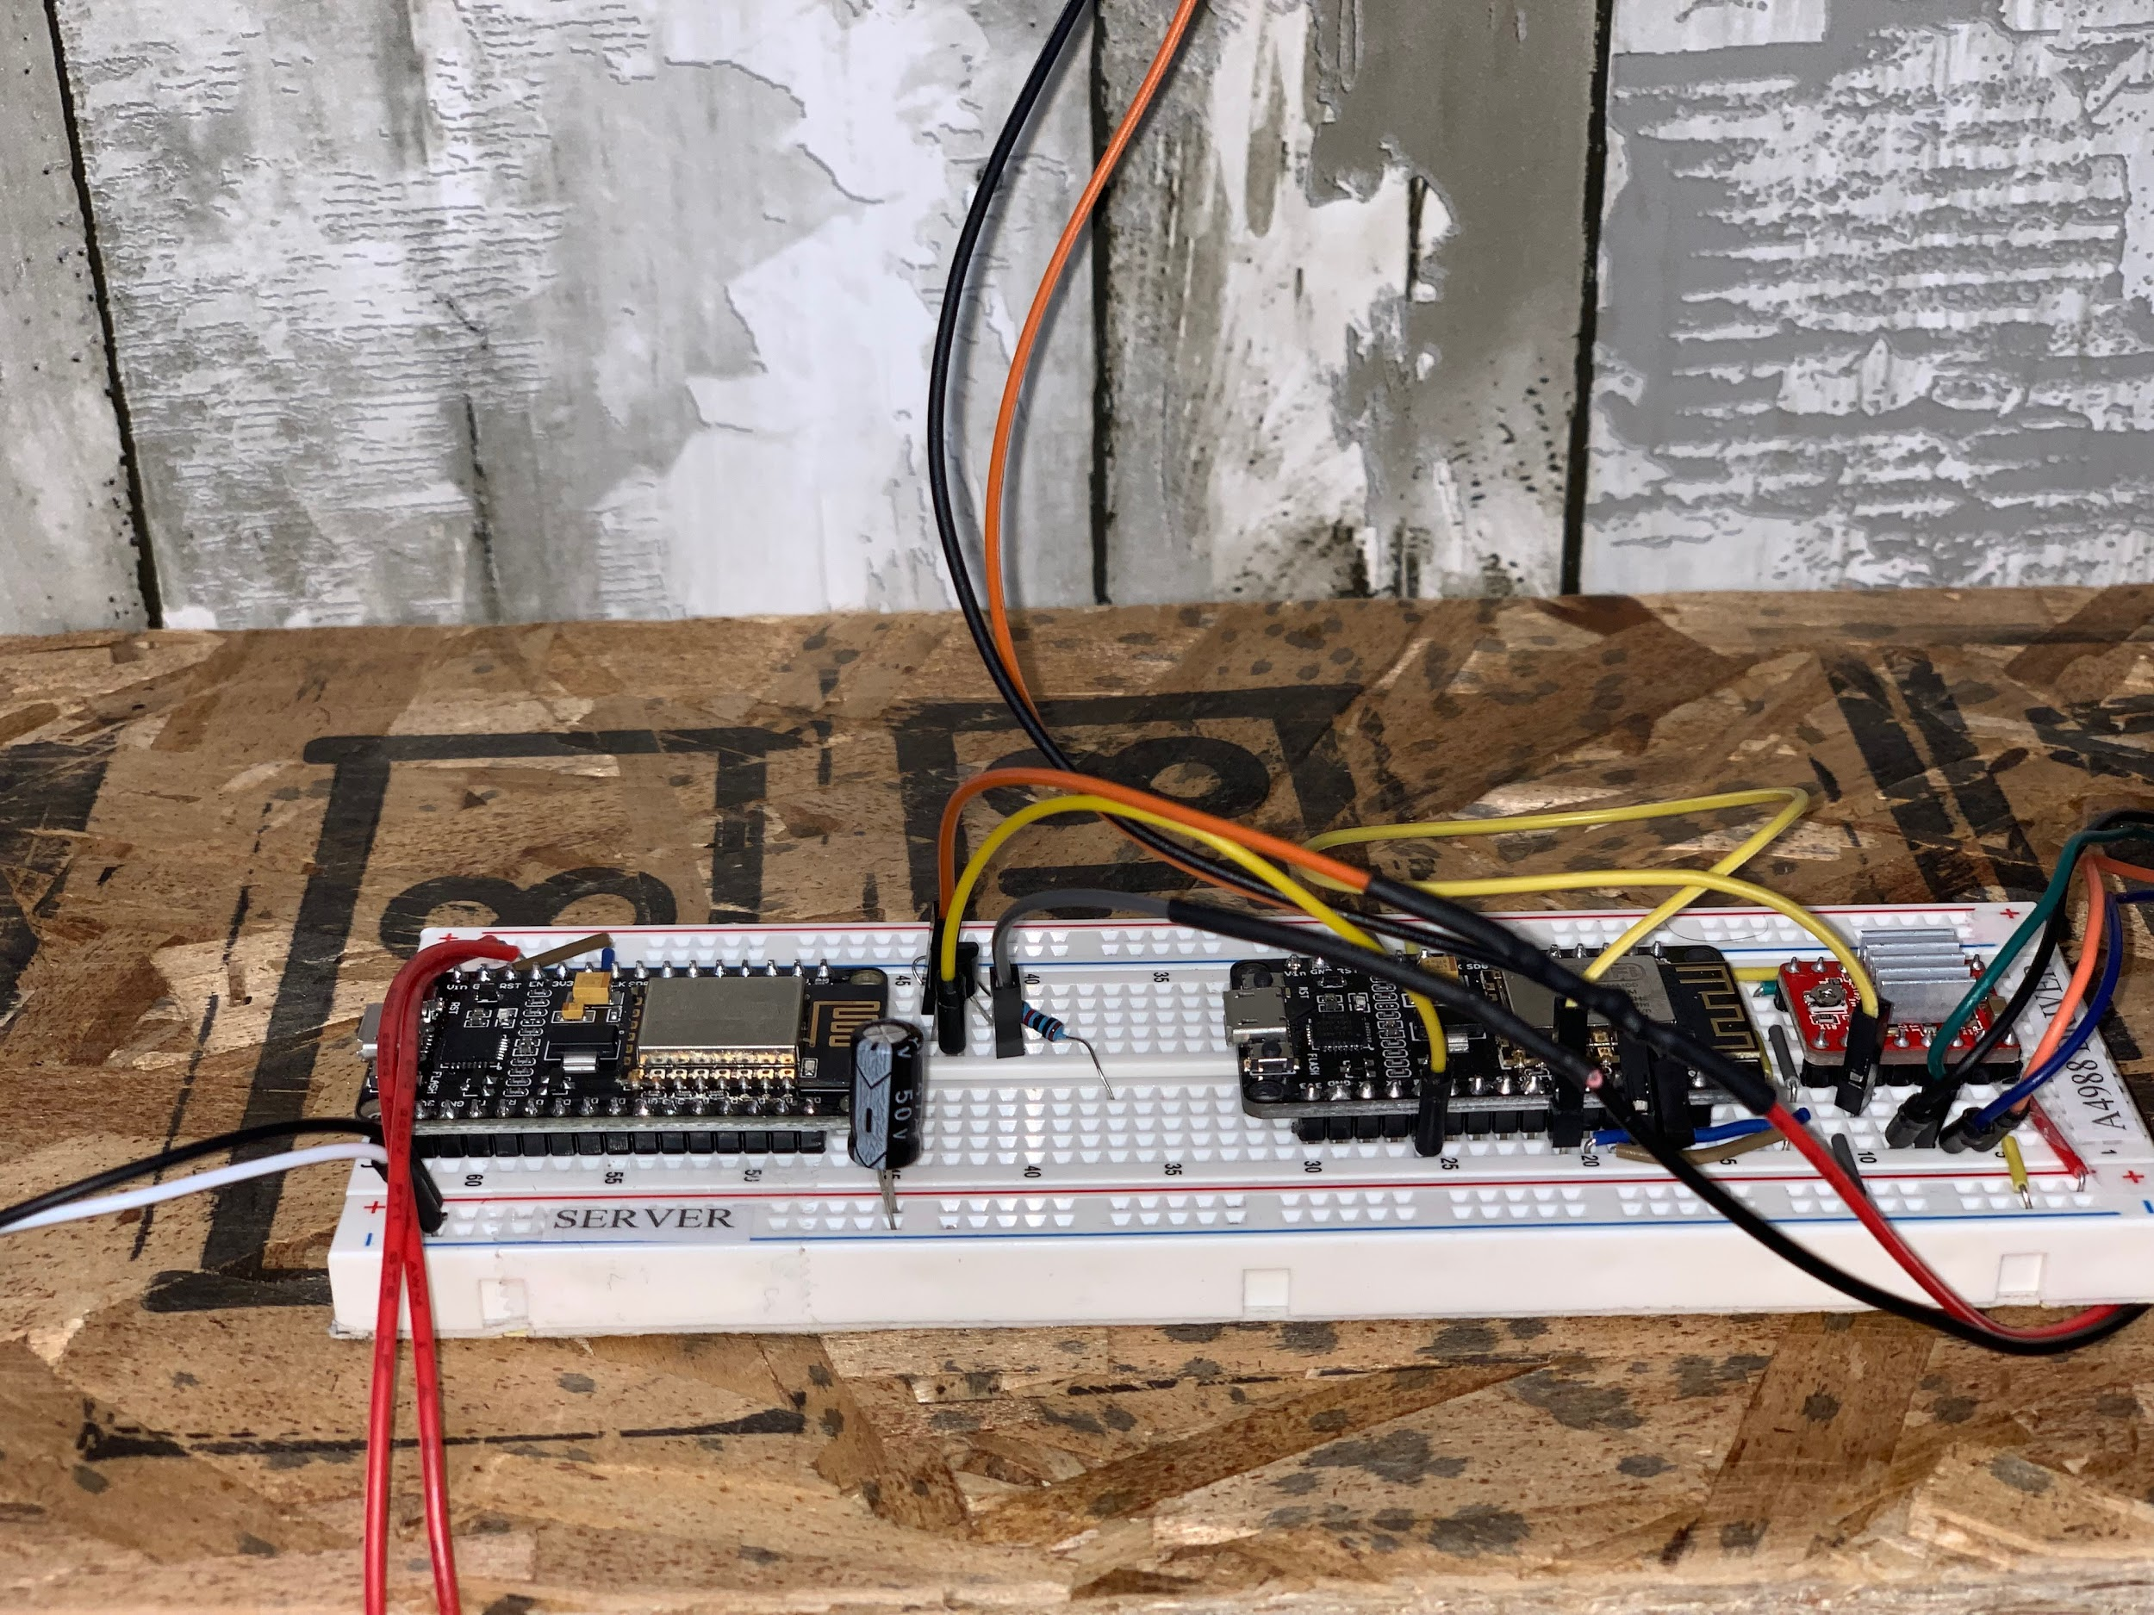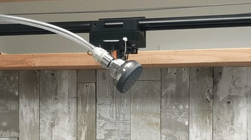

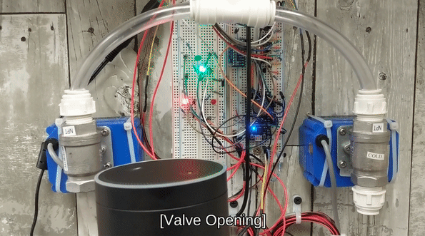

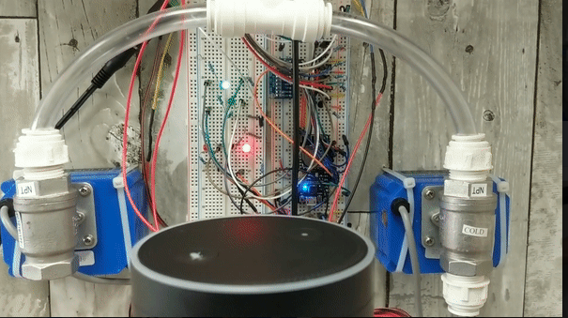

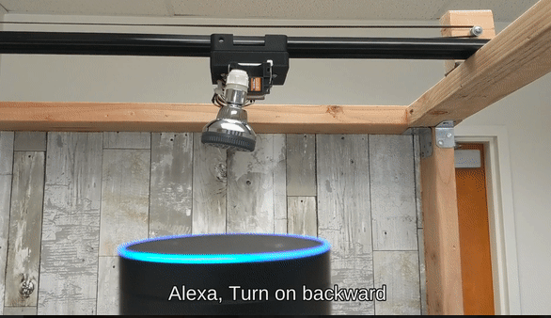

These images are what our final project has become after adding the motorized track, ultrasonic sensor, water valves, and server and clients. After, we did add the 20 Kg Servo motor that articulated the shower head from zero to forty-five degrees. The last three images show the functionality of the valves when the Alexa sends the request to fully open either the cold or hot valve the green led will turn on to indicate the valve is open else the red led will indicate it is closed and if Alexa receives the Forward/Backward it will send the signal to the Stepper Motor ESP8226.

**DISCUSSION OF RESULTS**

Our Stepper motor, Servo Motor and Water Controlled Valves are working as expected with both the Alexa and web based application on our final design. The webpage is a great alternative to Alexa. It has most of the features that were implemented with our Amazon Alexa Echo. Although this is only a prototype to a potentially marketable product, most of the project would have to be modified if it would ever be installed in a home, as well as potential issues like waterproofing and valve and water pressure modification will arise. The shower system works well in a controlled setting due to it being a retrofit allowing for ease of testing versus an upgrade to an existing shower. The system definitely has much more potential than just for this capstone project, and there is an abundance of room for improvement, but overall it proves to be a functional project.

# PROBLEMS ENCOUNTERED

The first problem we encountered was the design of the slider to move the shower head. In order to solve this problem we went through a couple different designs on how to best implement the movement of the shower head and settled with a modified camera slider. The second problem we encountered was that our schematic for the stepper motor was incorrect, we then had to do more research on the motor itself to find a procedure that would operate them correctly. Our third problem was interfacing our Amazon Echo with the ESP8266s using the Arduino IDE. We first tried creating an Alexa Skill and working through AWS Lambda but that was very difficult. We resolved this issue by using UDP packets, and Fauxmo Library to emulate a Belkin WeMo that helped us enable/disable our devices using voice commands with the presets that are implemented in our code. Additionally, we had issues with the track movement itself, whether the track dragged, or hitting that back of the shower, we were able to solve these dilemmas by reducing friction on the track, as well as install an ultrasonic sensor.

# INDIVIDUAL TASK ASSIGNMENTS

James Perez - In charge of interfacing Stepper Motor and Servo Motor with Arduino/ESP8266 MCU 1.0 with webpage. Helped in programming the communication between the Arduino/ESP8266 MCU

Hugo Simon - In charge of programming the hot and cold tap solenoids to control water temperature, and helping with Alexa programming and communication between Arduino/ESP8266.

Cory Longshore - In charge of building the demo frame and installing the components, and 3D printing parts for the demo shower as well as helping with Alexa programming

Jessica Diaz - In charge of helping with Alexa interfacing with ESPs using Arduino IDE.

**CONCLUSION**

In conclusion, we were able to hit our design goals by implementing 5 of the 6 original component designs. We got our final cost for the items we used and it is well under our estimated preliminary budget by $300. Throughout the process we figured out that interfacing with our devices through ESP8226s using our Amazon Alexa was the most difficult, yet most exciting, to see the functionality of how IOT can be implemented into most designs. Despite our many issues, most of our functionality worked as expected, if not better. Although facial recognition was not part of our final design, the project more than surpassed our expectations.

# FUTURE WORK

Future work would include image recognition that would create a user profile on an app and save the users preferences for faster setup. These preferences would include water temperature, shower head position, and angle. For facial recognition to work dynamically, machine learning would be utilized in order to learn the face and preferences of each independent user. Additionally, we would want to articulate the head of the shower to move left and right, not just in a fixed position. Also, since this IoT project is marketable, we would then want to make the entire shower piece interchangeable with a standard shower. This would mean that anyone with a disability, or a person with limited mobility could utilize this system to shower independently. Undeniably, waterproofing is a difficult challenge for us with this task; in the future, tackling this would require extensive rewiring, gasket installations, as well as other waterproofing entities.

# REFERENCES

[1] **“DIY Motorized WiFi Camera Slider,” *Novaspirit*, 03-Jul-2017. [Online]. Available: https://www.novaspirit.com/2017/07/01/diy-motorized-wifi-camera-slider/. [Accessed: 10-Oct-2018].**

**[2] “Nodemcu Stepper Motor Control Over WiFi,” Microcontroller Projects. [Online]. Available:https://www.microcontroller-project.com/nodemcu-esp8266-stepper-motor-interfacing.html. [Accessed: 05-Oct-2018].**

**[3]Kosinski, John R. “Get Started with IoT Development: An ESP8266 Arduino Tutorial.” *Toptal Engineering Blog*, Toptal, 8 Nov. 2017, www.toptal.com/arduino/esp8266-arduino-tutorial-alexa-hack.**